9 October 2024
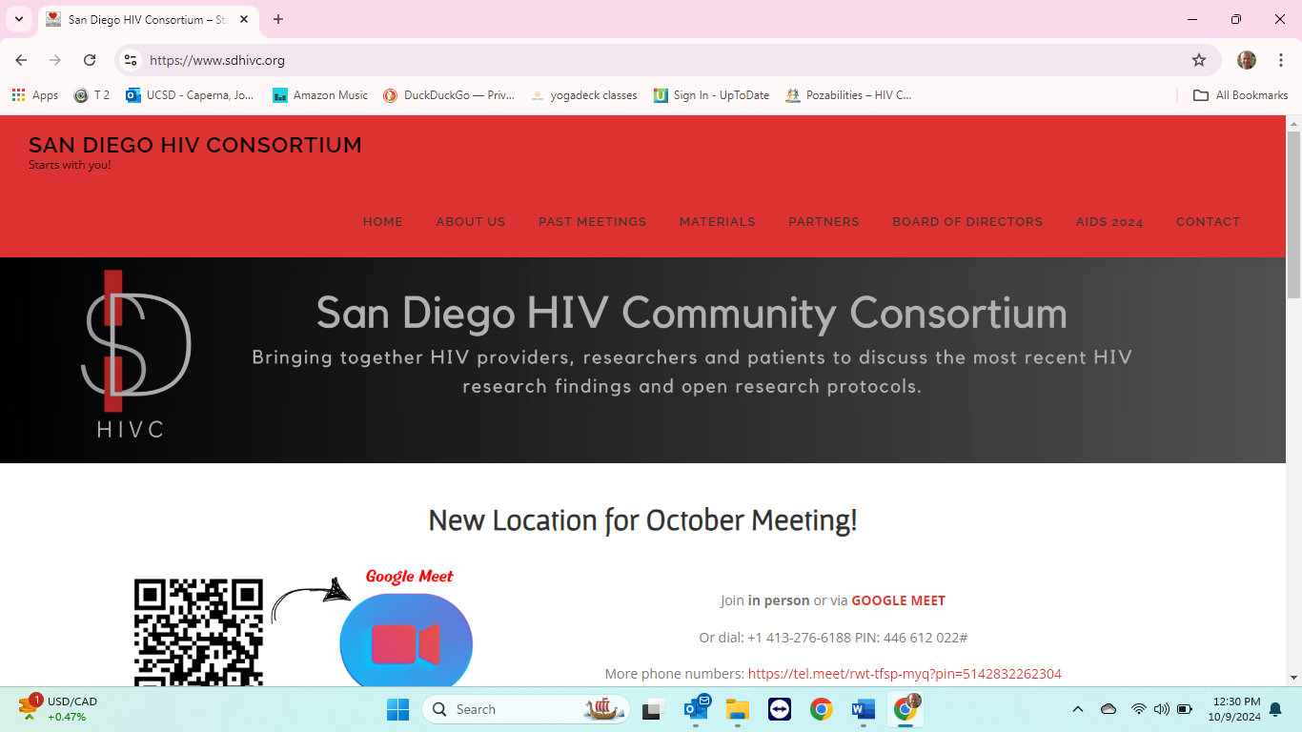

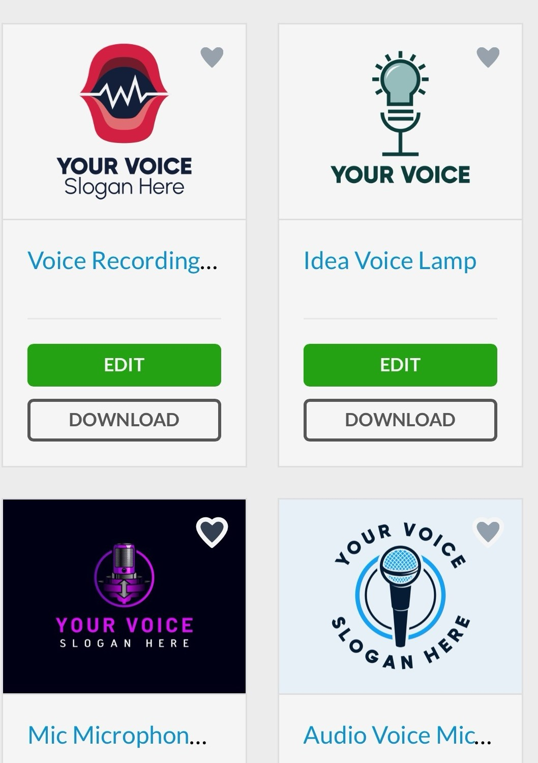
Thank you for being part of The Voice, a project to find out directly from people living with HIV what they want to help their mental health, by first asking you what your expereinces have been, what your needs are in your own words, and what suggestions you have for local health providers and researchers. We have formed focus groups of 10 or so each. We will then summarize the meetings and present to local HIV health providers and reserachers.

The Voice is a project by the San Diego HIV Consortium, part of Pozabilities. The Consortium is dedicated to bringing the newest advancements and also research opportunities in HIV to the local San Diego community. We’ve had several updates on treatment of mental health in people living with HIV (PLH); you can can find on our website sdhivc.org. Currently, there are no “clinical” intervention research studies in mental health in HIV in San Diego, i.e., studies in humans to treat, not just observe. This is our chance to have a voice in what studies the researchers should do and the results we want to see.

There is an obvious need for improved mental health services for PLH. The World Health Organization and our own government Department of Health and Human Services have made mental health in PLH a priority, but most of the research funding seems to be dedicated to methamphetamine, heroin and fentanyl. We as a community need to make this a priority for researchers. Finally, we have not been able to find any open research studies in San Diego on mental health in PLH.

“Your Voice” is a new project to address the mental health needs in PLH. The following groups with leaders have been formed to share your thoughts, needs and ideas about future research. Leaders will keep notes, summarize and send reports to a steering committee, which will meet in the end of December 2024.

In February 2025, we will have a joint meeting in Palm Springs with HARP-PS, a group similar to Pozabilities and the SDHIVC. In April 2025, we plan another joint meeting with HARP-PS in San Diego. Please see the timeline of our project below. Final reports will be sent and discussed with the County of San Diego and UCSD. Each group will have 10 participants, and a simple thank you with lunch provided.

- Women
- Transwomen
- Transmen
- Black
- AANHPI—Asian American, Native Hawaiian, Pacific Islander
- Latinx
- Youth
- Unsheltered
- LGB—Lesbian, Gay, Bisexual
- LTS-Long Term Survivors
- Artists Latinx
- Aging Artists
- Wholeness
- Sobriety
- UCSD CAB

Focus group leaders will share these four questions common to all groups, plus some specific to your group. Thank you again for helping this effort to improve mental health in PLH.

Sincerely,
John Steinmetz, President, SDHIV
Tony Alexander, Vice President. SDHIVC

