**Focus Group**

**On Mental Health Wellbeing in PLH**

Needs, Perspectives, Ideas to improve

[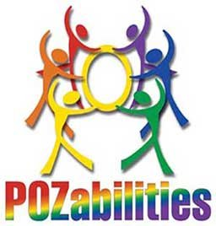](https://www.pozabilities.org/)

a project by SDHIV Consortium of Pozabilities, to inform researchers of needs directly from PLH

Currently, there are no “Clinical” intervention research studies in mental health wellbeing in HIV in San Diego, ie, studies in humans to treat, not just observe. This is our chance to have a voice in what studies the researchers should do and the results we want to see.

There is an obvious need for improved mental health well-being services for people living with HIV (PLH). The WHO and our own government DHHS have made mental health wellbeing in PLH a priority, but most of the research funding seems to be dedicated to methamphetamine, heroin and fentanyl. We as a community need to make this a priority for researchers.

*What do you think of when you hear ‘mental health wellbeing?’*

*What mental health wellbeing problems have you had, and what worked or did not work?*

*What do you suggest to help improve mental health wellbeing in PLH?*

*Do you have suggestions for what and how to research solutions or improvements in mental health wellbeing in PLH?*