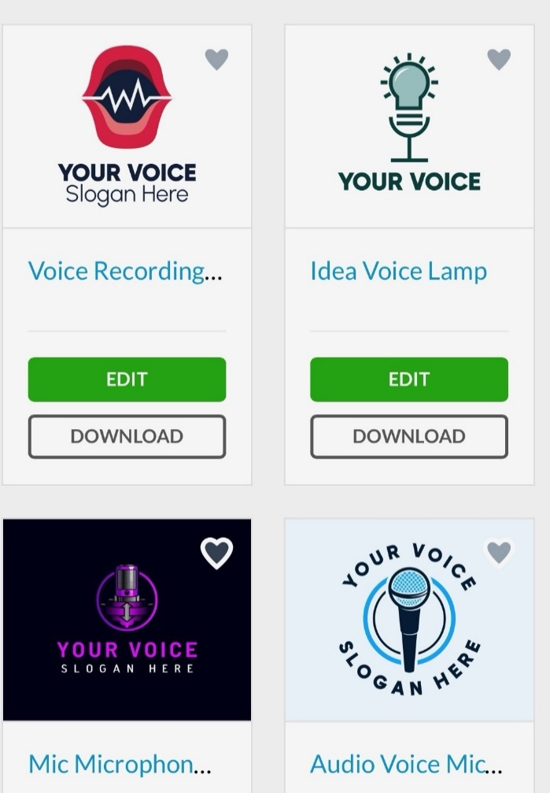
Instructions to Group Leaders—
- See intro letter,
- facilitate group,
- ground rules,
- summary report to include participants’
- Gaps in knowledge to equip them to find mental health services,
- Experiences with mental health services, if any, and
- Suggestions for research in mental health wellbeing in PLH.
- Suggestions for next focus groups, how to facilitate, agenda, etc.

